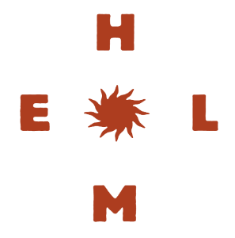
Christmas 26 Packages

$120 Per person
3 Hour Classic Beverage Package includes:
Carlton Draught, Great Northern Super Crisp, Hahn Super Dry, Carlton Dry, Cascade Premium Light & Great Northern Zero Alcohol
House Sparkling, Sauvignon Blanc, Cabernet Merlot,

House spirit and mixers
Balter Vodka, Milton Silver Rum, True Penny Gin, Ojala Blanco Tequila, Johnny Walker Red Scotch, Jim Beam Bourbon, Bundaberg Rum

Soft drink and Juice

Food a selection to share
Vegetarian mezze
Fried calamari
Truffled mushroom arancini
Souvlaki chicken wings
Selection of pizzas

$150 Per person
4 Hour Classic Beverage Package includes:
Carlton Draught, Great Northern Super Crisp, Hahn Super Dry, Carlton Dry, Cascade Premium Light & Great Northern Zero Alcohol
House Sparkling, Sauvignon Blanc, Cabernet Merlot,
House spirit and mixers
Balter Vodka, Milton Silver Rum, True Penny Gin, Ojala Blanco Tequila, Johnny Walker Red Scotch, Jim Beam Bourbon, Bundaberg Rum

Soft drink and Juice

Food a selection to share
Vegetarian mezze
Fried calamari
Truffled mushroom arancini
Souvlaki chicken wings
Selection of pizzas
Lamb kofta slider, lettuce, tomato, cucumber yoghurt
Battered dory, fries, tartare
Vietnamese rice paper roll
$170 Per person
4 Hour Deluxe Beverage Package includes:
All tap beers, Cascade Premium Light & Great Northern Zero Alcohol
House Sparkling, Sauvignon Blanc, Cabernet Merlot,
Cavaliere Prosecco, 821 South Sauvignon Blanc, Devils Lair Chardonnay
Tatachilla Rose, Petaluma White Label Pinot Noir, Grant Burge Benchmark Shiraz

House spirit and mixers
Balter Vodka, Milton Silver Rum, True Penny Gin, Ojala Blanco Tequila, Johnny Walker Red Scotch, Jim Beam Bourbon, Bundaberg Rum

Soft drink and Juice

Food a selection to share
Vegetarian mezze
Fried calamari
Truffled mushroom arancini
Souvlaki chicken wings
Selection of pizzas
Lamb kofta slider, lettuce, tomato, cucumber yoghurt
Battered dory, fries, tartare
Vietnamese rice paper roll

